**\*\*\* PUBLIC TOWN HALL MEETING \*\*\***

**Booth Memorial / Marian Pritchett School**

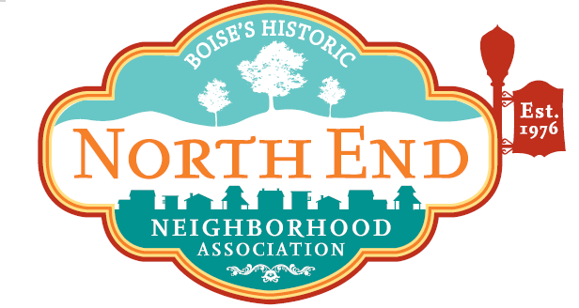

**Monday, March 12, at 6:30 – 8:30 PM  
in Lowell Elementary’s cafeteria, 1507 N 28th St.**

**Did you know?** A 2-acre parcel in our neighborhood, the Salvation Army’s Booth Memorial Campus at 1617 N. 24th St., is now for sale.   
The deadline for offers from buyers is April 27.

**Why it’s important:** The sale and redevelopment of this city block promises to change the nature of our community. It will potentially determine future residential density, traffic volume, property values, the continued existence of historic structures, and your future quality-of-life.

**We need your input:** We want to hear your views and ideas on the redevelopment of the Booth Home. The town hall meeting will help define our neighborhood’s vision for the area, and a final document will be provided promptly to decision-makers.

**The format:** Idaho Smart Growth will give a short presentation about the history and current status of the campus, followed by a summary of last year’s online survey results. Then, you will be asked to join your neighbors in a facilitated discussion to gather ideas and refine a community vision.

**Who is invited?** You! This is a neighborhood collaboration but is open to everyone, including potential buyers, developers, city leaders, and media.

**Hosted by:** North End Neighborhood Association & Idaho Smart Growth

**Questions?** board@northendboise.org