Safe Routes to School – Monthly Walk & Bike Fun Sheet
#1
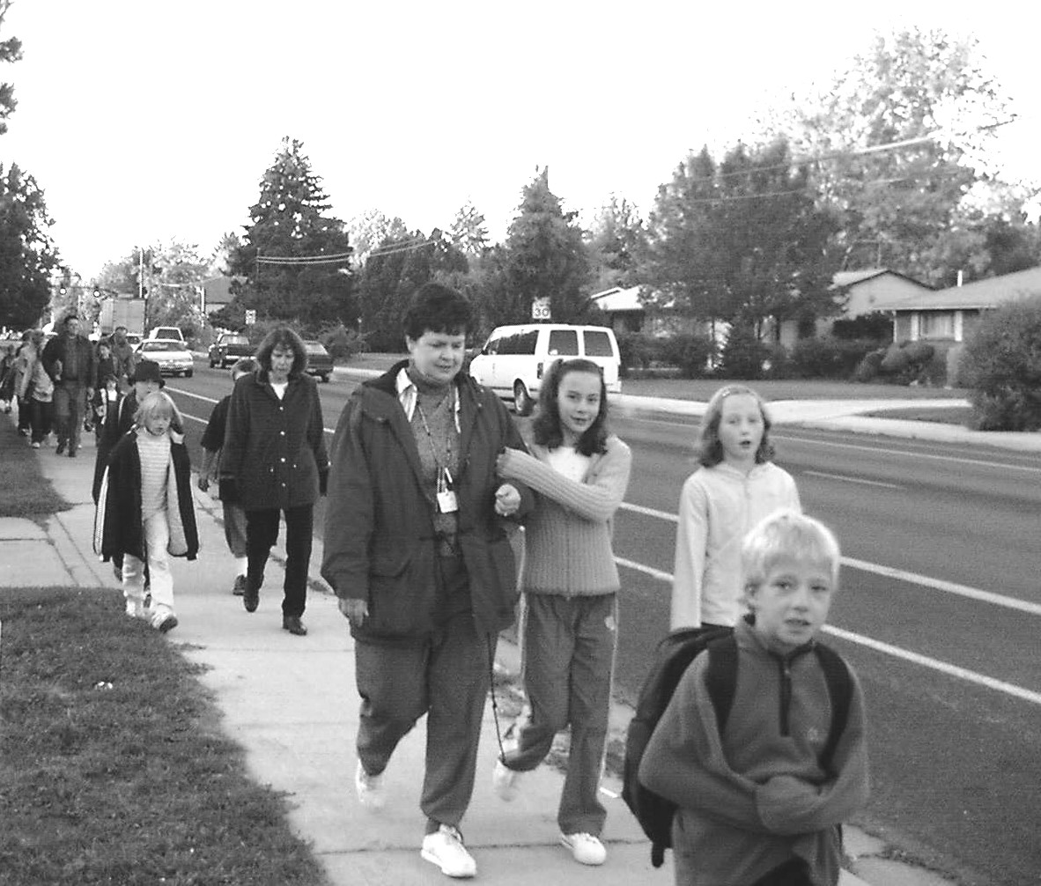
Parents and Guardians, there is a Safe Routes to School project at _____School Name ____ Contact us if you’d like to help. As part of the project, our volunteers will hand out monthly walk/bike fun sheets throughout the year. The sheets will include activities focusing on walking and biking safety and fun, trivia questions and announcements. We hope everyone will enjoy the activities and walk or bicycle to school as much as possible to have fun and be healthy.
WHO WANTS TO PARTICPATE IN Walk to School Day???
_School Name _ will be participating in Walk to School Day and would love to have you join us. We will identify group walking/biking routes. Sign up below to walk or ride your bike with us; your parent can join too:

Your name: Grade: _____
Check one: Walking ____ or Riding your bike: _____
(note: if riding your bike, you must have a helmet)

Parent accompanying you: _________________________
Check one: Walking ____ or Riding your bike: _____
(note: if riding your bike, you must have a helmet)
Phone Number or Email to confirm and give further details:

_______________________________________________
Please cut out and bring back to your teacher by Day of week the Date!!!
Add contact info here
This month’s reminder:
Join us on Walk to School Day!! Add date, time, meeting place(s) and other information for Walk to School here
Pedestrian Safety Word Search
Find the words in the Word Search that are in bold in these safety tips
- Walk with a buddy.
- Choose a route with sidewalks where possible.
- If there is no sidewalk, walk on the left side of the road.
- Listen for traffic.
- Be careful near cars coming in or out of driveways when you cross them.
- Walk, don’t run to cross the street.
- Wear reflective clothing or accessories when walking at night.
- Make eye contact with drivers when crossing their paths.
- Don’t talk or text while walking.
- Cross at corners with traffic signals if possible.
- Always look left-right-left when crossing.
R | N | A | C | O | L | P | H | D | S | O | S
P | E | E | M | A | S | E | R | M | I | G | I
A | I | F | T | E | R | I | F | U | D | C | T
T | X | D | L | S | V | E | C | T | E | Y | E
H | G | O | B | E | I | X | F | F | W | D | X
S | O | E | W | G | C | L | X | U | A | D | T
K | L | A | Q | Q | I | T | M | X | L | U | A
S | Y | S | L | A | N | G | I | S | K | B | Z
S | P | W | A | L | K | N | T | V | S | J | Y
D | C | R | O | S | S | V | F | K | E | T | D


Trivia questions to talk to your parents about:

Do skateboarders, scooters and other wheels have to stop for people walking across the street in crosswalks? (Answer in next month’s fun sheet.)
idahosmartgrowth.org
for more
information

