Safe Routes to School – Monthly Walk & Bike Fun Sheet
#2A
Thanks for Walking ! ! !
To everyone who has been walking and biking to school…Thank you very much. We sure hope you have been having fun. Watch for more tips on how to stay safe while you walk and bike.
Remember to be safe when walking to school or home
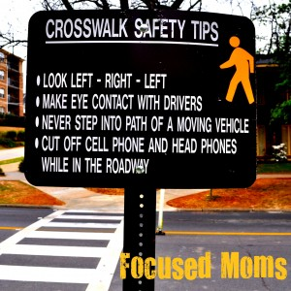
Walking to school tips
- Only walk on streets you know
- Always use crosswalks
- Never horseplay near busy streets
- Pay attention to your crossing guard
- Look both ways when crossing
- Be alert for dogs, emergency vehicles
- Wear good walking shoes
- Be careful crossing driveways
This month’s reminder: Reminder here

Trivia Answer from last month:
Do skateboarders, scooters and other wheels have to stop for people walking across street in crosswalks? Yes, they do. When on a street and on wheels you are the same as a car.
Trivia questions: Do you know your traffic signs?
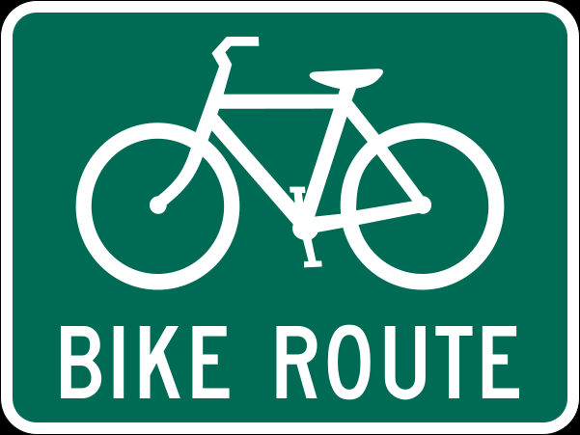
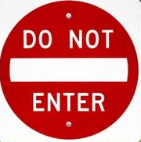
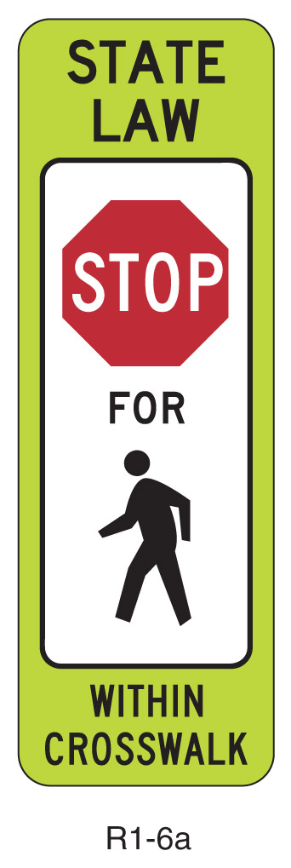
What word goes is missing here?
What Goes Here???
How About
Here?
←
A. Slow
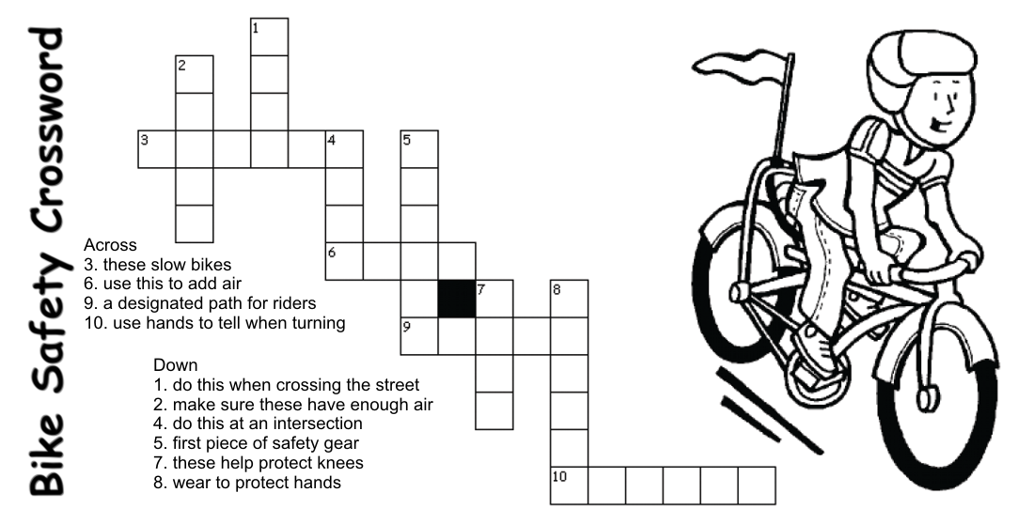

B. Yield C. Stop

