Safe Routes to School – Monthly Walk & Bike Fun Sheet
#4
We hope you enjoy Holiday Break. Remember to be safe while you’re having fun.
What activities would you like to do during the holiday break?:
This month’s reminder:
Reminder here
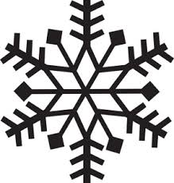
_____________________________________

_____________________________________


_____________________________________


_____________________________________
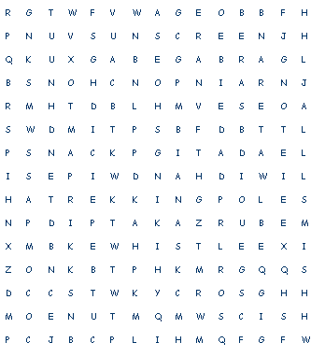
Hiking Word Search
Do you like to go on hikes with family and friends? Well if you do this word search will help you to remember the tools you may need to be prepared for your adventure. Here are the words you will need to find:
COMPASS POCKETKNIFE
FIRST-AID KIT RAIN PONCHO
GARBAGE BAG SNACK
HANDWIPPES SUNSCREEN
TREKING POLE HAT
HIKING SHOES WATER
MAP WHISTLE

Last month’s questions and answers:
- What side of the road should a bicyclist ride on? Always ride on the right side with traffic; drivers expect to see you there rather than on the left riding against traffic.
- What side should a walker walk on if there is no sidewalk? Always walk against traffic so that you see the oncoming cars, make eye contact and stay at a safe distance from them.
- List all the things you will need to ride a bicycle at night: Head light, rear light visible for 500 feet, reflectors and bright clothing.


This Month’s Trivia Question:
- Under Idaho law is a bicyclist considered a pedestrian or a vehicle?
- Does a bicyclist have to get off their bike before entering a crosswalk?

